**Chapter 1**

**PROJECT OVERVIEW**

**1. 1 Introduction**

The proposed idea for our Mini project for the Fifth Semester (2014-2015) is Home Automation based on Raspberry Pi. Automation is a broad concept in engineering and home automation is but a small subsidiary of this vast idea. Recently, the Internet Of Things has gathered momentum and many interesting applications have surfaced making many of the daily chores simple and efficient. We intend to implement a small scale home automation project using the Raspberry Pi. Raspberry Pi is a powerful credit card sized computer capable of running as a normal computer and also capable of running the functions of a microcontroller.

Due to the hardware limitations (limited no of input and output pins) of the Raspberry Pi, we are forced to interface additional microcontrollers to control the various sensors involved in the automation.

**1. 2 Objectives**

The system comprises automation of some daily tasks in our home. The

different functions of the system are:

• Adaptive Internal Lighting and automatic external lighting System

• Automatic Water Pumping System

• Password Enabled Door Lock using keypad

• Interactive Music Player

• Data logging and temperature measurement

**1.3 System Specifications**

* Raspberry Pi
* Atmega 328P (2)
* Serial Interface
* Power supply 5V, 2A
* Passive InfraRed (PIR)
* Real Time Clock (RTC)

**Chapter 2**

**SYSTEM OVERVIEW**

**2.1 Modules**

We use 4 individual modules in our project namely Raspberry Pi, Microcontroller (Atmega 328P), PIR sensor and an RTC (DS1307).

**2.1.1 Raspberry Pi**

Raspberry Pi is a single board computer. It has a Broadcom BCM2835 system on a chip (SoC), which includes an ARM1176JZF-S 700 MHz processor, VideoCore IV GPU with 256MB of RAM. But it does not come with a Real-Time Clock, though it can be interfaced with DS1307 through I2C.

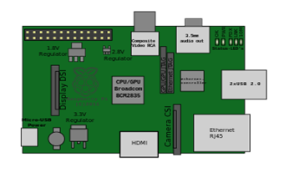

***Figure 2.1:-Raspberry Pi[3]***

**2.1.2 Microcontroller Atmega328P**

The high-performance Atmel picoPower 8-bit AVR RISC-based microcontroller combines 32KB ISP flash memory with read-while-write capabilities, 1024B EEPROM, 2KB SRAM, 23 general purpose I/O lines, 32 general purpose working registers, three flexible timer/counters with compare modes, internal and external interrupts, serial programmable USART, a byte-oriented 2-wire serial interface, SPI serial port, a 6-channel 10-bit A/D converter (8-channels in TQFP and QFN/MLF packages), programmable watchdog timer with internal oscillator, and five software selectable power saving modes. The device operates between 1.8-5.5 volts.

By executing powerful instructions in a single clock cycle, the device achieves throughputs approaching 1 MIPS per MHz, balancing power consumption and processing speed.

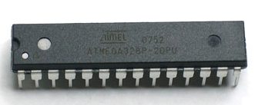

***Figure 2.2:- Atmega328P[2]***

**2.1.3 Passive Infrared (PIR) sensor**

A passive infrared sensor (PIR sensor) is an electronic sensor that measures infrared (IR) light radiating from objects in its field of view. An individual PIR sensor detects changes in the amount of infrared radiation impinging upon it, which varies depending on the temperature and surface characteristics of the objects in front of the sensor. When an object, such as a human, passes in front of the background, such as a wall, the temperature at that point in the sensor's field of view will rise from room temperature to body temperature, and then back again. The sensor converts the resulting change in the incoming infrared radiation into a change in the output voltage, and this triggers the detection. Moving objects of similar temperature to the background but different surface characteristics may also have a different infrared emission pattern, and thus sometimes trigger the detector.

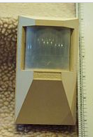

***Figure 2.3:- Passive Infra Red (PIR) Sensor[7]***

**2.1.4 LM35 Temperature Sensor**

LM35 is a precision IC temperature sensor with its output proportional to the temperature (in **o**C). The sensor circuitry is sealed and therefore it is not subjected to oxidation and other processes. With LM35, temperature can be measured more accurately than with a thermistor. It also possess low self heating and does not cause more than 0.1**o**C temperature rise in still air.

The operating temperature range is from -55°C to 150°C. The output voltage varies by 10mV in response to every **o**C rise/fall in ambient temperature, *i.e.,*its scale factor is 0.01V/**o**C.

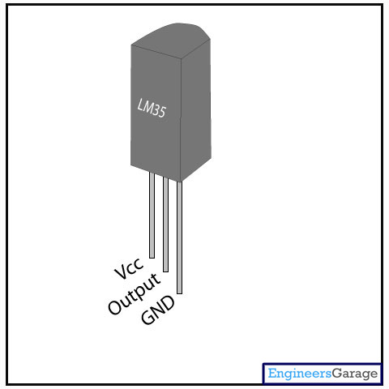

***Figure 2.4:- LM35 Temperature Sensor[6]***

**2.1.4 Real Time Clock (RTC)**

A real-time clock (RTC) is a computer clock that keeps track of the current time.

Main advantages are:-

1. Low Power Consumption

2. Frees the main system from critical time related tasks

3. More accurate than other methods

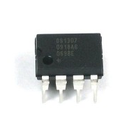

***Figure 2.5:- Real Time Clock (DS1307)[8]***

**2.2 Systems**

There are 6 systems or individual modules in our project. They are:

**2.2.1 Adaptive Internal Lighting System**

The Adaptive Internal Lighting System controls the amount of illumination in a room by controlling a light source, based on the amount of light present in the room. The sensor involved is a light dependant resistor (LDR) which varies it's resistance depending on the amount of light falling on it. The change in resistance will result in a change in the voltage drop across the resistance (a varying analog signal). For demonstration purposes we intend to use an LED, the brightness of which is controlled by Pulse Width Modulation.

**2.2.2 Automatic External Lighting System**

This feature of our project controls an External Lighting System based on the amount of external light. When the light outside falls below a specific value , the light is turned on. It also makes use of a LDR.

**2.2.3 Automatic Water Pumping System**

Through this system we intend to control the water pump based on the water level inside the water tank. This prevents the overflowing and wastage of water which is a pristine and scarce resource. The water level is determined by two sensors and the output is used by Raspberry Pi to drive a relay that switches the water pumping system.

**2.2.4 Password Enabled Door Lock System**

This feature adds to the security of the smart home. A 4*3 keypad is interfaced with the microcontroller which is then connected to a door lock system. The door lock gets unlocked when the correct password is entered.

**2.2.5 Interactive Music System**

This part of the project adds to the entertainment in the smart home. A simple music player is integrated with the Raspberry Pi which can be controlled using small buttons for functions like play, pause etc.

**2.2.6 Data logging and Temperature Measurement**

This feature comprises of the data logging and event tracking feature of our project. Data logging includes the temperature measurement and event logging. It can be used to analyze the working of the home. Temperature measurement is done by lm35 and logged in Raspberry Pi.

**2.3 Block Diagram**

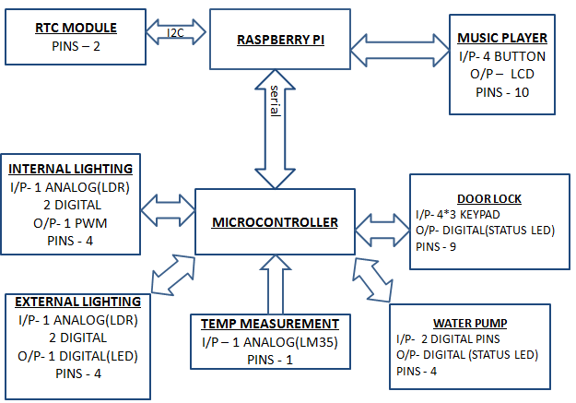

***Figure 2.6:- Block Diagram***

**2.4 Serial Communication**

The universal asynchronous receiver/transmitter (UART) takes bytes of data and transmits the individual bits in a sequential fashion. At the destination, a second UART re-assembles the bits into complete bytes. Each UART contains a shift register, which is the fundamental method of conversion between serial and parallel forms. Serial transmission of digital information (bits) through a single wire or other medium is less costly than parallel transmission through multiple wires. Communication may be simplex (in one direction only, with no provision for the receiving device to send information back to the transmitting device), full duplex (both devices send and receive at the same time) or half duplex (devices take turns transmitting and receiving).

There are two modes of Serial communication - the synchronous and asynchronous mode. In synchronous mode, both the transmitter and the receiver work in synchronization with each other. In Asynchronous mode, the transmitter and the receiver are not synchronized. The speed of transmission of data is given by the baud rate. The baud rate represents the number of bits sent per second. The standard baud rates used in serial communication are 4800, 9600, 115200 etc.

In synchronous mode, the clock signal is recovered from the data stream and both the transmitter and the receiver work in synchronization with each other. In the case of asynchronous transmission, there is a start and stop bit that denotes the starting and stopping of the communication. The start and stop bits are sent in addition to the 8 data bits.

The mode that we are using is UART (asynchronous mode) with a baud rate of 9600.

**Chapter 3**

**SYSTEM DESIGN**

**3.1 Adaptive Lighting System**

It takes in the analog input from the LDR and the corresponding voltage is transmitted into the microcontroller.

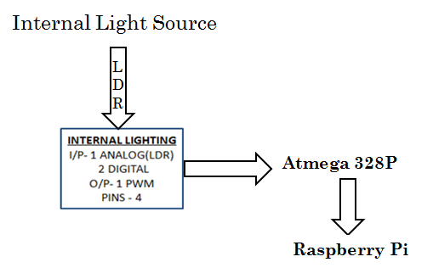

***Figure 3.1:- Flowchart of Adaptive Internal Lighting System***

**Hardware Requirements:-**

* LDR
* LED
* Power Supply- 3.3V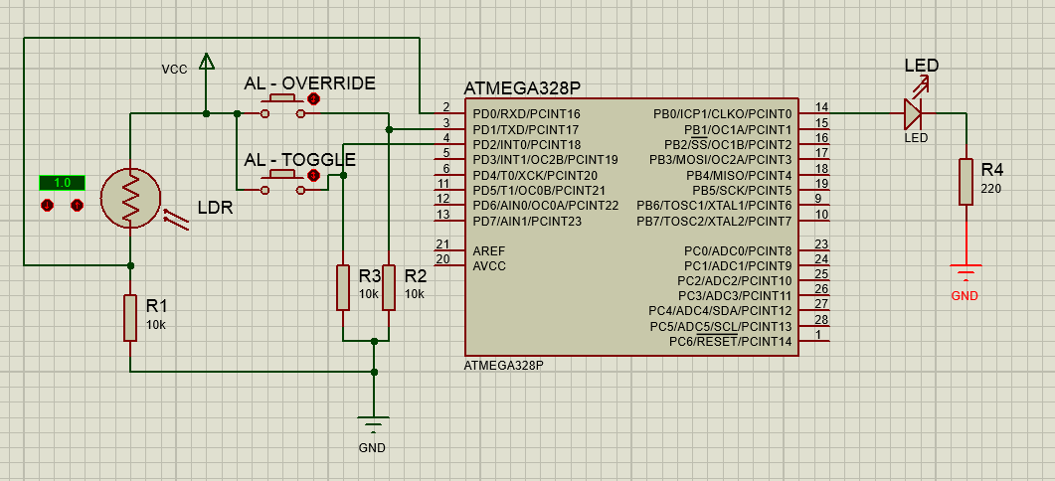

***Figure 3.2:- Adaptive Lighting System Design***

**3.2 Automatic External Lighting System**

It takes in the analog input from the LDR and the corresponding voltage is transmitted into the microcontroller.

**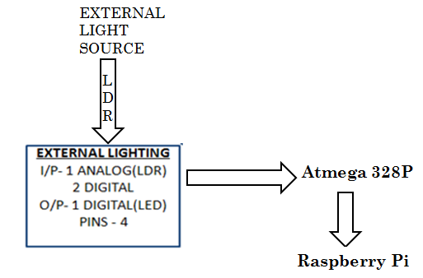*Figure 3.3:- Flowchart of Automatic External Lighting System***

**Hardware Requirements:-**

* LDR
* LED
* Power Supply- 3.3V

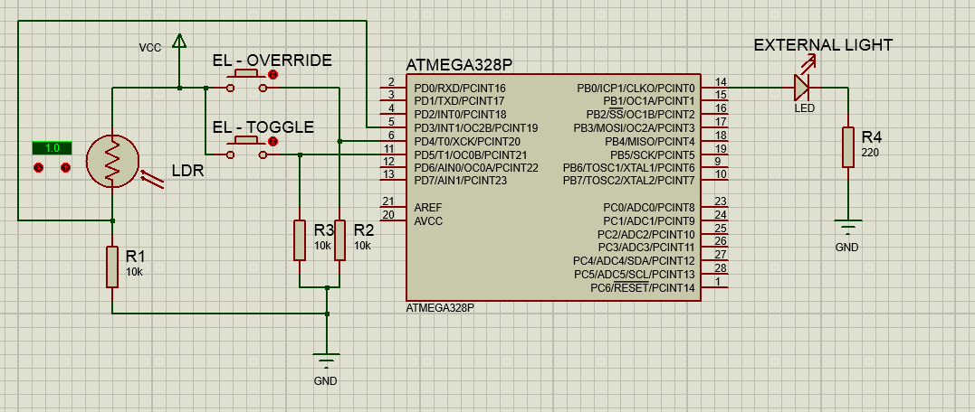

***Figure 3.4:- Automatic Lighting System Design***

**3.3 Automatic Water Pump System**

It uses 3 sensors namely for the bottom tank, low level of top tank and high level of top tank. The water is pumped from the bottom tank to the top tank. The sensors send the output of the water level from the top tank to the microcontroller and the microcontroller controls the motor accordingly.

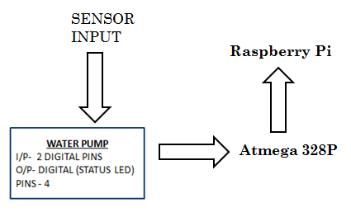

***Figure 3.5:- Flowchart of Automatic Water Pump System***

**Hardware Requirements:-**

* Relay
* L293D
* Power Supply-5V

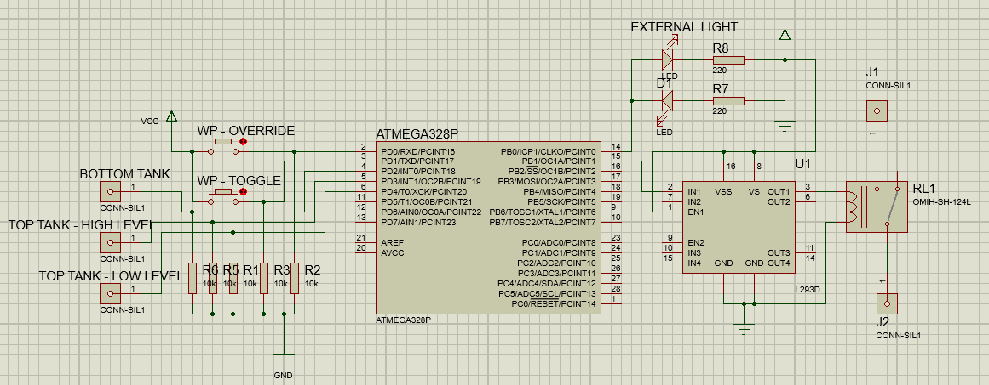

***Figure 3.6:- Automatic Water Pump System Design***

**3.4 Password Enabled Door Lock**

The system takes in the input password from the keypad, the microcontroller checks it with the preset password and controls the motor accordingly.

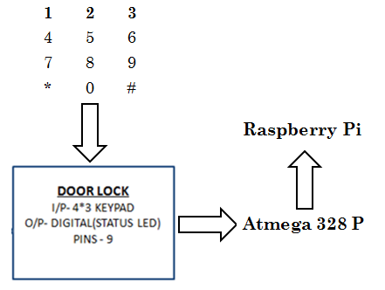

***Figure 3.7:- Flowchart of Password Enabled Door-lock System***

**Hardware Requirements:-**

* Relay
* Keypad
* L293D
* Power Supply-5V

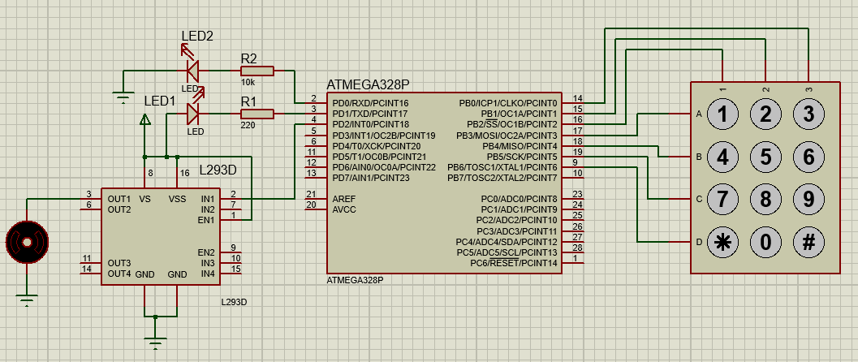

***Figure 3.8:- Password Enabled Door Lock Design***

**3.5 Interactive Music Player System**

There are 4 buttons namely PLAY,PAUSE,NEXT SONG,PREVIOUS SONG which are connected to the raspberry pi. Also an LCD is interfaced with the raspberry pi which displays the current title of the song being played.

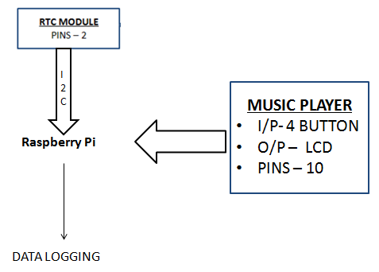

***Figure 3.9:- Flowchart of Interactive Music Player System***

**Hardware Requirements:-**

* Push Buttons
* Speaker (headphone)
* LCD
* Power Supply-5V

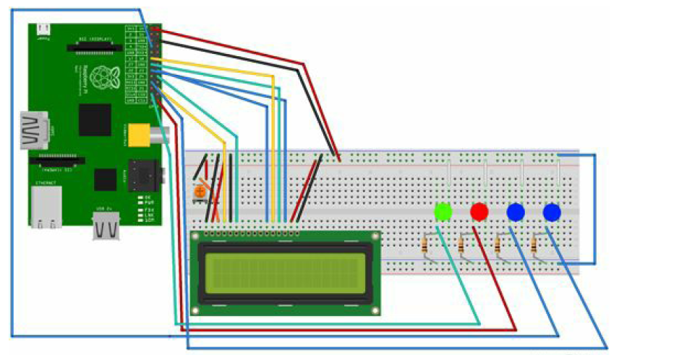

***Figure 3.10:- Interactive Music Player System Design***

**3.6 Power Supply**

The power supply generates 5V output which is required to drive the L293D and also the DS1307.

**Specifications:**

* 5V, 2A

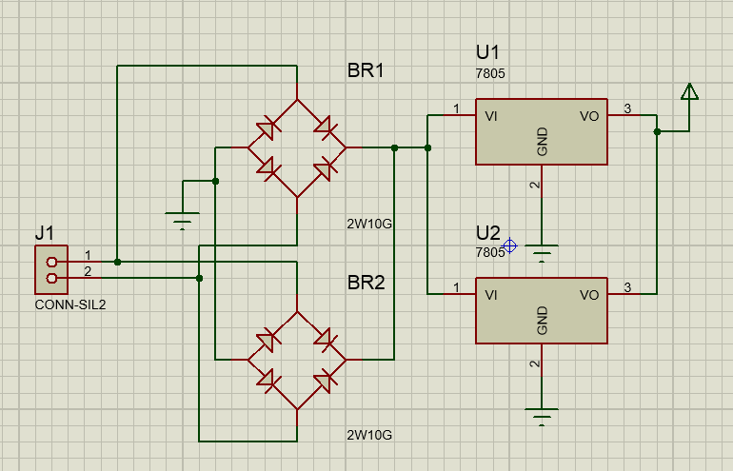

***Figure 3.11:- Power Supply Design***

**3.7 Real Time Clock (RTC)**

The DS1307 provides the real time for the system. It aims at low power consumption.

It oscillates with a crystal frequency of 32.768kHz.



***Figure 3.12:- Flowchart of RTC System***

**Hardware Requirements:-**

* DS1307 RTC chip - A low power, full binary coded decimal serial real time clock.

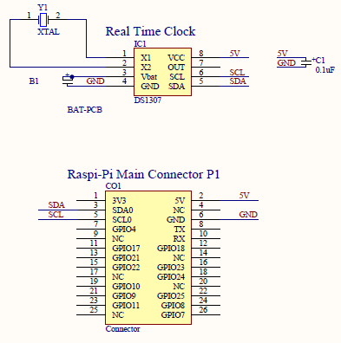

***Figure 3.13:- Real Time Clock Module Design***

**Chapter 4**

**PCB FABRICATION AND SOLDERING**

**4.1 PCB Fabrication**

The materials required for PCB fabrication are copper clad sheet, little paint drilling machine and ferric chloride solution.

The PCB fabrication involves the following steps:

**4.1.1 Preparation of the PCB layout**

The layout is commonly prepared in the scale of *2:1*. It offers a reasonable compromised below accuracy gain and handling convenience as *2:1* part of art work has the actual PCB area. Grid systems are commonly used for preparation of the layout. The use of the grid sheet gives more convenience in placement of components and conductors. The grid system based on 0.1 is found to be too coursing, a grid equidistant of *0.1mm* is recommended.

**Procedure:**

• Each and every PCB is viewed from component side.

• The designing of the layout is started with an absolutely clear component list and circuit diagram.

• The large components are placed first and the space in between is filled with smaller area.

• In the designing of a PCB layout, it is very important to divide circuit into sub units. Each of these sub units are realized in the defined portion of the board.

• The components are placed in the print sheet tanning and standard length and width.

• The punched component layout is circled to taking the standard size of the land pads.

**4**.**1.2 Pattern transfer**

After the film is processed the film master are obtained. The transfer of the conductor which is on the film master on to the copper clad base material is done by two methods mainly photo printing and screen printing. Photo printing is extremely accurate which is also applied to the fabrication of semiconductors. Screen printing is comparatively cheap and simple method for pattern transfer although less precise than photo printing. But this is less costly, so this method is commonly used.

**4.1.3 Screen printing**

In screen printing, the processing is very simple. A screen fabric with uniform meshes and opening stretched and fixed on a solid frame of metal or wood. The circuit pattern is photographically transferred on to queue through the opening master onto the surface of the material to be printed. The light sensitive material is coated on to the screen and using film master the pattern is transferred to the screen. Then using ink the pattern is transferred to the copper clad sheet. Two methods are used for screened printing pattern into screen.

1. Direct method

2. Indirect method

In direct method the photographically sensitive film is transferred to screen. The film is exposed and then pasted to the screen. The pattern is then transferred to screen using the links and squeegee.

**4.1.4. Etching**

The removal of unwanted copper from copper clad sheet is known as etching.

For these 4 types of tanks are used.

1. Ferric Chloride

2. Cupric Chloride

3. Chromic acid

4 .Alkaline ammonia

Among these Ferric Chloride is cheap and also suited for home and industrial applications. The high corrosive power of FeCl leads to short etching time and little under etching. Ferric chloride matches well photo and screen printed resists.

**4.1.5 Drilling**

Drilling of components, mounting holes into the PCBs is by the most important mechanical machining operation in PCB production process. The importance of hole drilling on PCB has further group with electronic component miniaturization and its need for smaller hole diameters and higher packing density where hole punching is practically routed out.

Four types of drilling are commonly used.

1. Drilling by direct sight

2. Drilling by optical sight

3. Jig drilling

4. NC drilling

**4.1.6 Component mounting**

Component is basically mounted on one side of the board. On polarized two lead components are mounted to give the marking or the orientation throughout the board. The component orientation can be both horizontal as well as vertical but uniformly, direction is placed. The uniformity in orientation of polarized component is determined during design of PCB.

**4.2 Soldering and Desoldering**

**4.2.1 Soldering**

Soldering is a process of joining two or more dissimilar metals by melting another metal having low melting points.

**4.2.2** **Soldering Flux**

In order to make the surface accept the solder readily, the component terminals should be free from oxides and other obstructing films. Soldering flux cleans the oxides from the surface of metal. The leads should be cleaned chemically or by scrapping using blade. Small amount of lead should be coated on the portion of leads and the bits of soldering. This process is called tinning. Zinc Chloride, Aluminum Chloride and rosin are the most commonly used fluxes.

**4.2.3 Solder**

It is an alloy of tin and lead, typically 60% tin and 40% lead. It melts at a temperature about 473K. Coating a surface with solder is called tinning. Solder used for electronic purposes contain tiny cores of flux, like the wires inside the main flux. The flux is corrosive like an acid and it clears the metal surface as the solder melts. This is why we melt solder on the joints, not on the iron tip.

**4.2.4 Soldering Tips**

It is the tool used to melt and apply solder at the joints in the circuit. It operates in 230V main supply. The normal power ratings of the soldering iron are 10W, 25W, 35W, 65W, 125W.

**4.2.5 Preparing the Soldering Iron**

* Place the soldering iron in its stand and plug it in. The iron will take a few minutes to reach its operating temperature of about 673K.
* Dampen the sponge in the stand.
* Wait for a few minutes for the soldering iron to warm up.
* Wipe the top of the iron on damped sponge.
* Melt little solder on the tip of the iron.

**4.3 PCB Design**

We have incorporated our entire components into a single PCB, in order to sell it as a product in the market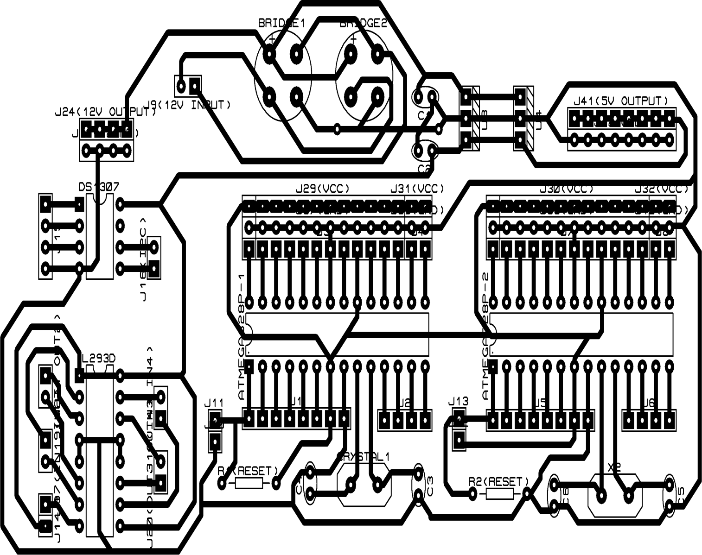

***Figure 4.1:- PCB Layout***

**Chapter 5**

**SOFTWARE**

**5.1 Microcontroller 1- Program**

Microcontroller 1 controls the internal adaptive lighting system, automatic external lighting system and temperature measurement system. The analog input is taken from the LDR of the lighting system and converted to a DC value which is compared to a preset threshold values and the light intensity is controlled using it. The temperature is measured using LM35 sensor.

**5.2 Microcontroller 2- Program**

Microcontroller 2 controls the Water Pump and Door Lock System. There are sensors located in the water tank at the top and bottom, which controls the motor pump. The keypad used is 3*4 which has 7 output lines connected to the microcontroller. A password is stored in the EPROM of the microcontroller, the user entered password is checked with the pre stored password. “ * ” when pressed within the allocated time is used to change the preset password in the microcontroller.

**5.3 Raspberry Pi Programs**

There are 2 programs stored in the Raspberry Pi. They are:-

**5.3.1 Music Player Program**

There are 4 buttons namely PLAY,PAUSE,NEXT SONG,PREVIOUS SONG which are connected to the raspberry pi. Also an LCD is interfaced with the raspberry pi which displays the current title of the song being played.

**5.3.2 Data Logging Program**

Initially a protocol is established for each systems and the serial communication and data logging is programmed using this protocol. A 2 byte data is serially transmitted to the raspberry pi from the microcontrollers, the first byte represents the system and the second byte represents the status of the system. The raspberry pi compares the received bytes with the preset protocol and logs the corresponding data. The temperature from the LM35 as such is stored in the Raspberry Pi.

**Chapter 6**

**CONCLUSION**

**6.1 Observation**

* In this work, we have implemented Home Automation using Raspberry Pi.
* The two Atmega Microcontrollers were programmed successfully.
* The design and implementation of the individual systems was successful.
* Serial communication between various devices was successful.
* Data was successfully logged in the Raspberry Pi.

**6.2 Future Scope**

The scope for improvement is immense. The data log from sensors can be shared over the internet and algorithms be implemented to take intelligent decisions regarding the power consumption etc. It could also be used to monitor the national average etc. We could also incorporate wireless sensor networks (WSN) for efficient power management. Raspberry Pi can be configured to act as a radio transmitter. This acts as an emergency radio service. The keypad can be replaced by a voice recognition system. Also we could integrate voice control to almost all the features. The various sensors can be connected to the central microcontroller unit via Zigbee Modules.